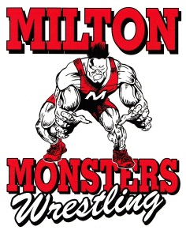
Milton Monster Mash Wrestling Tournament
Sunday, Feb. 19th, 2017
Milton High School,
114 W. High St., Milton, WI
Weigh-Ins 7:00-8:30 a.m.
Wrestling starts by 10:00 a.m.
Cost is $15.00
$2.00 Spectator Fee (12 & older)
USA Card Required
Folkstyle 8-Man Bracket with Wrestle-Backs to 3rd Place
Birth Year Brackets
2002-03, 2004-05, 2006-07, 2008-09, 2010-12
Monster Trophies for 1st-3rd Place, Medals for 4th-8th
Limited to FIRST 500 Participants through www.Trackwrestling.com
Absolutely NO walk-ins, NO Substitutions or Refunds
8 Quarter Mats for 2006-2012 and
4 Half Mats for 2002-2005
Full Concessions and Wrestling Gear available all day.
Contact Info: Kyle Kieliszewski (608)335-9936
Steve Haldiman (608)751-0151

